T-Shirt Order Form for SafetyBanners.Org

When completed, email this form to Cyndi Metz at cmetz@SafetyBanners.Org.

Ship To Information:
Company Name:
Attention:
Address 1:
Address 2:
City:
State:
Zip:
Telephone #:

Ordering Person:
Telephone #:
Email:

Design Information Number/Name:

Order Quantity by Color for our standard colors:

Black: S___ M___ L___ XL___ 2XL___ ($2 more) 3XL___ ($4 more) 4XL___ ($6 more)

Asphalt: S___ M___ L____ XL___ 2XL___ ($2 more) 3XL___ ($4 more) 4XL___ ($6 more)

Athletic Gray: S___ M___ L___ XL___ 2XL___ ($2 more) 3XL___ ($4 more) 4XL___ ($6 more)

Navy Blue: S___ M___ L___ XL___ 2XL___ ($2 more) 3XL___ ($4 more) 4XL___ ($6 more)

Royal Blue: S___ M___ L____ XL___ 2XL___ ($2 more) 3XL___ ($4 more) 4XL___ ($6 more)

Other Color: Insert the color name from the color palette below __________________________

S____ M____ L____ XL____ 2XL____ ($2 more) 3XL____ ($4 more) 4XL____ ($6 more)

NOTES: Not every color is available in the 4XL size. Total available colors are on Page 2 below. Production time is typically 4 business days but, may be longer depending on the color of t-shirt you choose and the order quantity. After we have your order, we will email you an onsite delivery date.

We will call you to get your credit card information for this order.

YOUR NOTES: __________________________________________________________________________
Have Questions? Call or email Cyndi.
Email – cmetz@safetybanners.org
Telephone: 901-759-0932 Central Time

NOTE: Colors as displayed on a computer monitor or a local printer are not necessarily 100% accurate as your monitor and printer are not calibrated to the actual t-shirt fabric color profile.

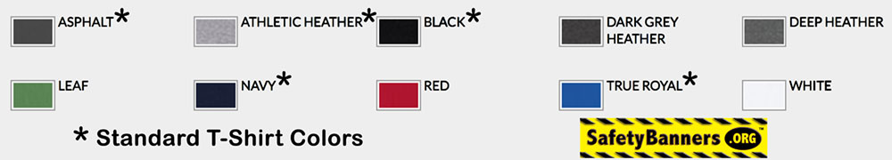

SafetyBanners.Org – America’s Largest designer and Manufacturer of Industrial Safety Banners.
Memphis, Tennessee
901-790-0932

